Report 2 Part 1

Pool Control System

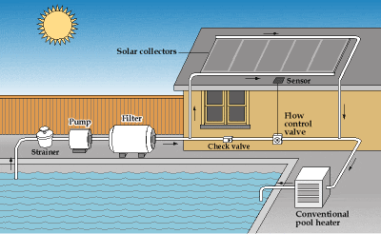

by Unknown Author is licensed under

Team BST – Members:

Steven Rioux

Taft Barrott

Brenton Dube

Table of Contents

* p4 Interaction Diagrams
* p? Project Management and References

**Individual contributions:**

**Steve:** (insert)

**Taft:** (insert)

**Brenton:** Created report skeleton and added new file to Git repository.

Interaction Diagrams

**Overview**

Do interaction diagrams for the use cases you elaborated (“fully dressed”) in Report #1. You should do at least sequence diagrams, but you may do some other UML interaction diagrams, as well.

Describe what design principles you employ in the process of assigning responsibilities to objects. This can be done either as comment “bubbles” in the diagram, or in the caption of the diagram.

Read the UML textbook about interaction diagrams and Section 2.5.1 in the course lecture notes, in order to learn about good design principles

Project Management and References

**Overview**

If you have a pool,